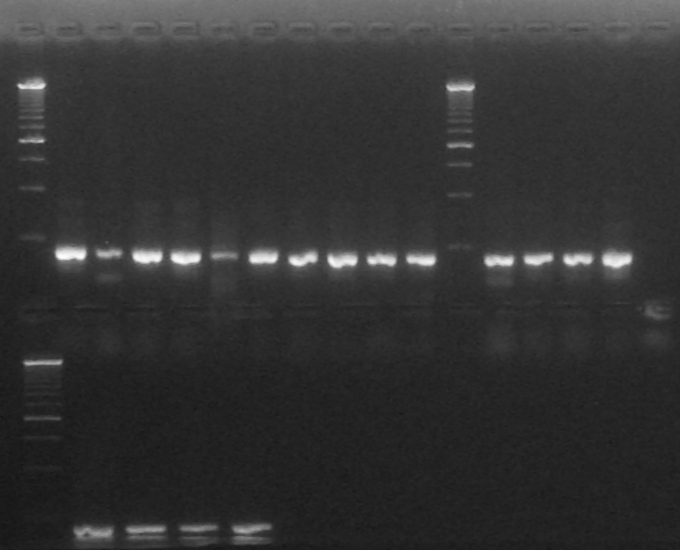
1 2 3 4 5 6
1 2 3 4 5 6 7 8 9 10 11 12 13 14 15 16 17

Arriba
Calle 1: Ladder 250pb
Calle 2: Colony PCR G4 #1
Calle 3: Colony PCR G4 #2
Calle 4: Colony PCR G4 #3
Calle 5: Colony PCR G4 #4
Calle 6: Colony PCR G4 C-
Calle 7: Colony PCR G3 #1
Calle 8: Colony PCR G3 #2
Calle 9: Colony PCR G3 #3
Calle 10: Colony PCR G3 #4
Calle 11: Colony PCR G3 C-
Calle 12: Ladder 250pb
Calle 13: Colony PCR G2 #1
Calle 14: Colony PCR G2 #2
Calle 15: Colony PCR G2 #3
Calle 16: Colony PCR G2 #4
Calle 17: Colony PCR G2 C-

Abajo
Calle 1: Ladder 250pb
Calle 2: Colony PCR G1 #1
Calle 3: Colony PCR G1 #2
Calle 4: Colony PCR G1 #3
Calle 5: Colony PCR G1 #4
Calle 6: Colony PCR G1 C-
1 2 3 4 5 6 7

